
Newsletter
The Colour Circle Inc.
555 Nelson Road, Mt Nelson, Tas. 7007
Email: thecolourcircle@gmail.com July 2022
Website: thecolourcircleinc.com
Editors: Susan Finlay and Barbara Etter

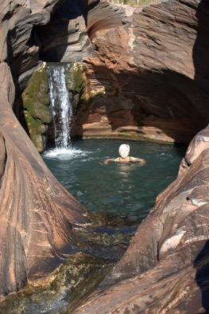
PRESIDENT’S REPORT

We all make art in different ways so here I am making art in the Spa Pool at Hammersley Gorge! What on earth do I mean by that? I hear some of you ask whilst others might be nodding in agreement.
When I travel, I often paint, sketch and take reference photos for later works but sometimes I prefer to just soak up the scenery, listen to the sounds and take more time to really notice all the little details. What better way to paint this stunning pool than to store up physical, emotional and mental memories that I can call on later when I’m using pastels or paint to try and capture the feeling of coolness, the sound of the trickling waterfall and those slippery, slippery rocks.

Taking time to immerse yourself in your preferred subject matter can really pay dividends when it comes to your art. How do you immerse yourself?

I hope you’ve all been able to find ways to be creative as the winter months set in. It gets colder and less welcoming for those hardy Plein Air painters amongst us so perhaps you’re spending more time sketching inside? If you do go out despite bad weather why not share some of your tips for coping with wild, windy and wet days?

We also have some exciting news for you all. Our application to the Salamanca Arts Centre to hold our 2023 exhibition in the Long Gallery has been accepted so we can look forward to a wonderful venue with lots of passing visitors. We’ll let you know more details as we firm up the date and the theme so that you can begin working towards preparing your entries.

Wishing you all a warm and creative winter.

Lindy Whitton
President

CLASSES FOR TERM 3
BOOKINGS OPEN ON 9 JULY at 10.00AM
To Make a Booking go to: thecolourcircleinc.com

Oil Painting with JOAN HUMBLE
Mondays 9:30am - 12:30pm
25 July - 12 September. 8 weeks

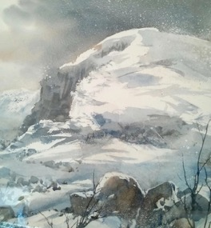
Painting with Friends -
Heritage Art Group Exhibition Preparation
Mondays 1.00pm - 4.00pm
25 July - 26 September
10 weeks

Watercolour Painting
with LYNNE BROWN
Tuesdays 9.30 am to 12.30 pm
16 August - 20 September
6 weeks

Painting with Friends - All Media
Tuesdays 1.30 pm to 4:30 pm
26 July - 27 September
10 weeks

Contemporary Painting in Oil and Acrylic
with AMBER KOROLUK STEPHENSON
Wednesdays 9.30am to 12.30pm
27 July - 14 September
8 weeks
Reduction Linocut Printmaking
with ANGELA COOPER
Wednesdays 1:30pm - 4:30pm
27 July - 14 September
8 weeks

Painting with Friends - Mixed Media
Thursdays 10:30 am to 12:30 pm
28 July - 29 September
10 weeks
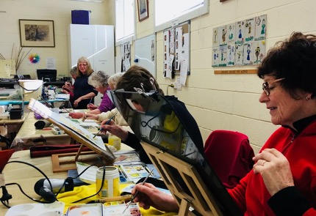

BOTANICAL DRAWING with Tanya Scharaschkin
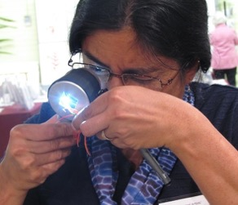
A one-day workshop held this term combined art and science to examine and draw plants accurately. It gave an overview of what’s involved in creating a piece of botanical art. It developed an understanding of the structure of flowers and leaves and taught the basics of botanical drawing.
Tanya examines a flower (photo: Kath Kreswell)
Tanya is a botanist by training and much of her time is spent introducing others to the world of plants through her Art
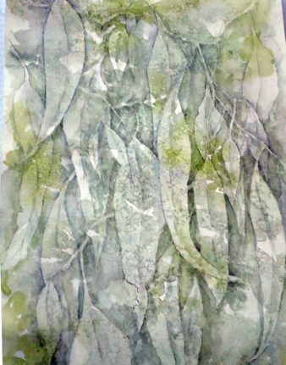
Tanya was a full-time plant systematist (botanist) and academic in Queensland until mid-2017. She moved to Tasmania in mid-2018 and now is a self-employed, free-lance scientist, teacher and artist. She hopes her art will inspire others to not only admire plants but also develop an understanding and appreciation of the biology of plants.

Botany and Botanical Drawing: These short courses combine botany with botanical drawing. Most botanical classes focus mainly or entirely on observation and drawing. But she also provides an additional angle by incorporating basic plant biology and explanation of plant structure.
Botany for the Artist (or any non-scientist): These workshops are targeted to plant enthusiasts (such as artists and gardeners) who want to learn more about plants. They spend a lot of time observing and dissecting flowers and coming to terms with botanical terminology. These workshops enable artists to appreciate plant diversity and plant biology and gain confidence incorporating scientific detail into their art.
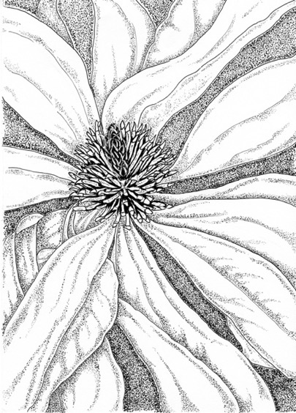

FUN ART TRIVIA – TAKE THE TEST
Take the test and see how well you know your art trivia.

- Which famous painter was also a sculptor, an architect and an engineer?
- The artist Kadinsky is considered the first for this type of art?
- Which of Picasso’s famous paintings was inspired by the bombings of civilians during the Spanish War?
- The American Gothic is one of the most recognisable paintings in the world. Who painted it?
- Who was the first living person to have their art displayed in the Louvre?
- Where did Vincent Van Gogh paint the famous “Starry Night”?
- What is the Mona Lisa missing?
- Salvador Dali is associated with which art movement?
- Who designed the Guggenheim Museum?
- Which French artist is well known for his obsession with ballerinas?
- Which abstract expressionist was known for using the “drip technique”?
- In which town in Italy was Leonard da Vinci born?
- Which artist was struck in the face by a fellow envious artist with a mallet leaving him terribly disfigured?
- Which artist is famous for Pop Art?
- What are the three primary colours?

Answers at the end of this newsletter!

GRANULATION IN WATERCOLOUR by Lynne Brown

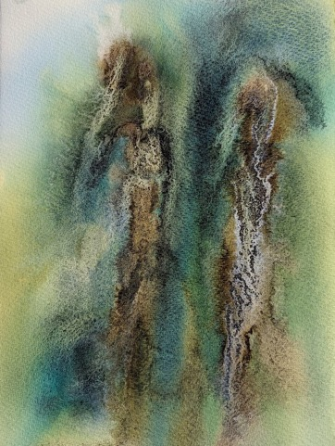
One of the most beautiful characteristics of watercolour is the range of textures it can produce. Some colours produce a smooth even wash, but others create beautiful mottled and granular patterns as they dry. This is called “granulation”, and it is unique to watercolour. While some people prefer smooth, even colour, most people love the extra dimension granulation can add to their painting.

So, what is a granulating watercolour? When you lay down a wet watercolour wash, at first the pigments are suspended in the water. As the water evaporates, the pigments settle onto the paper. Granulating pigments have larger, heavier, or more irregularly sized particles than non-granulating pigments, and so they sink into the paper under the influence of gravity. On smooth hot-pressed paper the pigments tend to settle randomly and create a mottled effect, but on cold-pressed or rough watercolour paper the pigments tend to fall into the valleys of the rough paper surface and create a grainier effect.

The brand and grade of paint can influence the amount of granulation, since the formula varies a lot between manufacturers. Granulation has become a very popular quality in paints in recent years, and brands like Daniel Smith and Schminke have been putting out more and more granulating pigments in response. Their online colour charts will tell you whether the paint is granulating or non-granulating. Cheaper, student grade watercolours tend to granulate less because their paint formula generally contains less expensive pigment and more cheap filler.

Certain coloured pigments have more sedimentary qualities than others. There are a good range of granulating colours in the blues, purples, earth colours and blacks, but true reds and yellows are rare. Schminke have just put out the first really granulating red (Volcano Red) and yellow (Volcano Yellow) that I know of. My favourite granulating colours are the ultramarines, cobalts, and earth colours such as the siennas and umbers. As anyone who has been to one of my classes knows, I also use a lot of Daniel Smith’s Lunar Black!

One way to enhance the textured effect of granulation is to use granulation medium. This is a liquid solution which you can add to your watercolours, either by diluting your tube paints directly with the medium, or by mixing on the paper, by brushing or dribbling the medium onto fresh washes. You can also use acrylic ink with the medium for some dramatic effects. I prefer the Winsor and Newton granulation medium to Schminke’s one. There are some “homemade” recipes out there, including Jean Haines’s one in her latest book, but I haven’t found any of them particularly effective. I have found that the key to success with granulation medium is to use LOTS of water and to rock the paper around gently, then to leave it alone. You can’t control what happens very much and if you stir it up with a brush it whilst it’s trying to settle, it will go muddy. Just sit back and watch the magic happen – it’s fascinating watching paint dry!

Some ways to use granulating qualities in your painting are:
- To make a flat wash more interesting and varied and to add additional texture.
- To describe textures seen in life, e.g., rust, moss, rocks, plaster, concrete, bricks, rough surfaces.
- naturally see as blurred or as a collection of dots, e.g. mountain rocks and sand and gravel on a seashore.
- To add an organic, whimsical or more abstract touch to a painting, because it’s a bit out of your control.

Using granulation in your painting adds interesting marks and textures which are unachievable in any other way or in any other medium. Try it and have fun!

A PLEIN AIR CLASSES by Susan Finlay
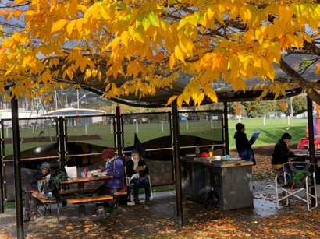
This term a group from The Colour Circle have been braving the elements to paint outside in various sites around Hobart.
Despite the rain and freezing weather on some days, we were able to find shelter where needed and we even enjoyed glorious sunshine to paint views of and around our beautiful city.
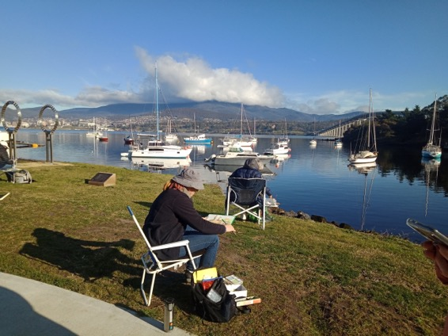
We painted at the Cenotaph, the Botanical gardens in the shelter of the Conservatory, Taroona Beach, Marieville Beach, Taroona Beach, Montague Bay and the Waterworks Reserve. A special thanks to Mel Hill who was our intrepid tutor, and a wonderful facilitator.

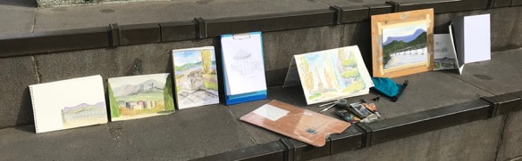

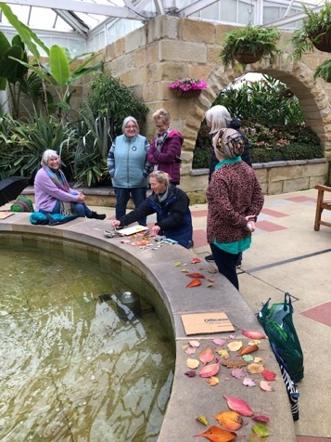

UPCOMING EVENTS

2022 Rotary Club of Hobart Art Show
The Rotary Club of Hobart is currently accepting entries into its 2022 Art Show being held at Wrest Point Casino from 9 to 11 September 2022. To enter simply visit the website rotaryhobart.com.au. Terms and conditions are available on the website. For further information contact Mel Knuckey, Co-Chair, Art Show Committee on 0407 512 315 or email artshow@rotaryhobart.org

For Calligraphy Lovers:
Kickstart Arts offer a range of art related workshops. Check out their workshop program at https://www.kickstartarts.org/creative-exchange
As an example, there is a workshop "Calligraphy for Beginners" with Peter Seeking to be held Sunday 17 July 2022 at the Art Room, 12 St Johns Ave New Town. Cost ranges from $78 to $105.

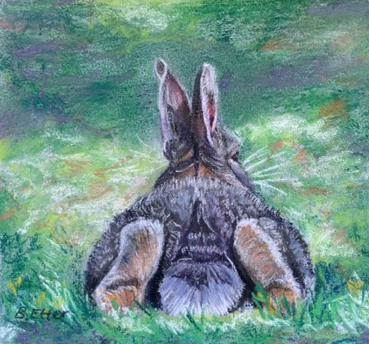
The Australian Society of Miniature Art Tasmania Inc (ASMA) will hold its 2022 National Annual Awards Exhibition "Little Gems" at the Rosny Schoolhouse Gallery from 13 October to 6 November 2022. Categories include: Seascape and Boats; Landscapes (including buildings); Portraits and Figures (animals and people;) and Still Life, Floral, Abstracts. (See Pastel Mini by Barbara Etter below).
Think about trying your hand out on a Miniature and entering this upcoming exhibition. Entry is open to ASMA members and sister societies in NSW or Victoria.
The Society has been running for many years now and has some outstanding Miniaturists. The Society was very pleased to recently welcome Rob Pennicott as its Patron.
Australian Pastel Expo 31 August to 4 September 2022 by Barbara Etter
The Australian Pastel Expo is on next month at the Events Centre in Caloundra, on Queensland's Sunshine Coast. If you are a keen pastellist then this is one not to miss!
I paid and had my bags packed for the 2020 event, but the event was cancelled due to Covid. I had attended the event 4 years ago and learnt so much. The presenters/tutors, including leading artists from overseas, were so inspiring. The trade show is like being a kid in a lolly shop with so many brands of pastels and papers on display. Enjoy some retail and art therapy all at the same time.
There will be 4 huge days of workshops, demonstrations, plein air painting, special events, an exhibition and more. A great chance to network and pick up new skills and materials.
Check out the website at https://www.australianpastelexpo.com.au/
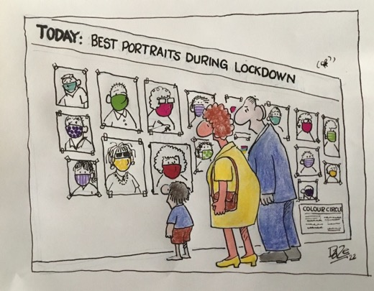
Answers to Quiz

- Leonarda da Vinci
- Abstract
- Guernica
- Grant Wood
- Georges Braque
- From his room at the asylum at Saint-Remy-de-Provence
- Eyebrows
- Surrealism
- Frank Lloyd Wright
- Edgar Degas
- Jackson Pollock
- The village of Vinci near Florence
- Michelangelo
- Andy Warhol

A Hugh thank you to everyone who has contributed to this issue of The Colour Circle newsletter.
Without you it would be a lot thinner!
Remember you can email in any story related to art at any time and we will find a place for it in the next issue of the newsletter.
Some suggestions for the next newsletter:
An unusual art activity you participated in;
A new medium you tried and fell in love with;
One item in your art materials collection you wouldn’t be without;
Something you have in your art hoard that you’ve never used– take it out and try it –then tell us all about your experience! Your favourite online art resource.
A peek into your sketchbooks; Your favourite painting subject and write a review of an exhibition you attended
We would love to hear from you so get writing

