Atmosphere and Mood in Watercolour

With Lynne Brown

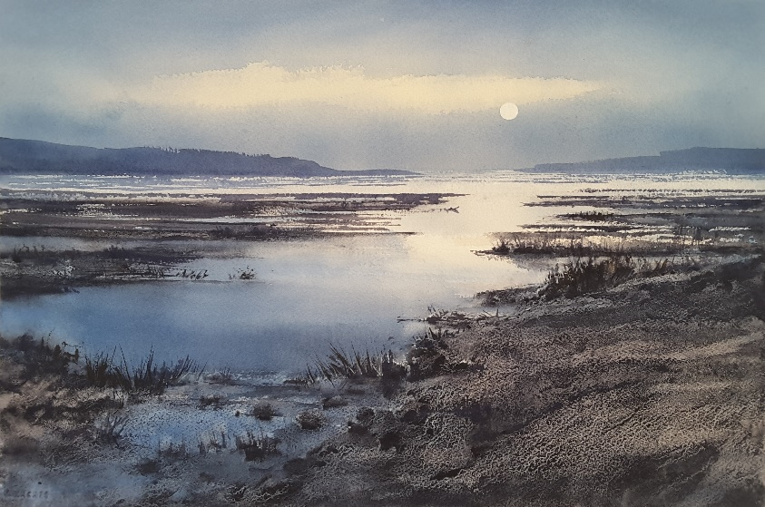

With its subtle effects, watercolour is a perfect medium for creating paintings full of mood and atmosphere. Atmosphere and mood refer to the emotion that an artwork evokes in a viewer. When we can convey a mood in our painting, it becomes more than a picture, it becomes an image that conjures feelings and memories – it becomes art.

Over four classes, we will look at the four elements: Water, Air, Earth and Fire and explore different ways you can enhance your paintings’ mood.

Suggested materials list

* **Artists’ quality watercolours:** Ultramarine Blue, Permanent Alizarin Crimson or Permanent Rose, Burnt Sienna, Raw Sienna or Yellow Ochre, Aureolin, Nickel Azo Yellow or another transparent yellow but NOT cadmium yellow.
* Optional but very useful: Cobalt blue, Cerulean blue
* Masking fluid
* Brushes – A selection of watercolour brushes: Size 10 and 12 rounds are good. A synthetic flat brush, a rigger for detail and a soft hake brush for washes are useful if you have them.
* 300gsm watercolour paper, medium (cold press) texture. Good quality cotton paper such as Arches is essential!
* Cartridge paper or “draw and wash” paper for practice and sketching
* Notebook or art journal
* Backing board for your paper
* Tape: masking tape (not blue tape as it affects your colour perception)
* A white palette, tile or plate for colour mixing
* A 2B pencil and eraser
* Tissues
* Your usual painting kit
* a desk easel if you wish to use one. Alternatively, you can use a rolled-up towel or block of wood to prop up your board and provide a slope.

This is just a suggested materials list. I will have lots of supplies for you to try and if you are unsure about what to get, just bring some good quality paper along and whatever other materials you have to the first lesson. I am happy to provide advice about what to get as we go along.

Lynne Brown

0466787054